Date o f Quote | In your own words, what does this quote mean? | Look at Eisenhower’s life event listed next to the quote. What is the connection between the quote and Eisenhower’s life event? | What does this quote tell you about Eisenhower’s character and personality?
 |  |  | 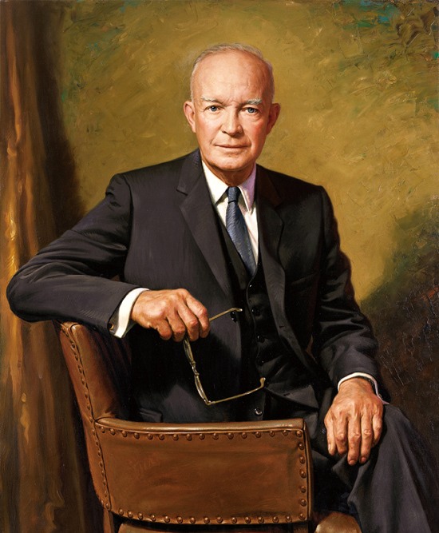
Date of Quote | In your own words, what does this quote mean? | Look at Eisenhower’s life event listed next to the quote. What is the connection between the quote and Eisenhower’s life event? | What does this quote tell you about Eisenhower’s character and personality?

Think About It: Out of all of the quotes you chose to analyze and even the ones you did not choose, which three do you think say the most about his character and personality?

